8-Queen Problem

AIM: To write a Python program to solve the 8-Queen Problem by placing eight queens on a chessboard so that no two queens attack each other.

Algorithm:
- Start the program.
- Initialize an empty 8 × 8 chessboard.
- Place a queen in the first row.
- Check whether the selected position is safe from other queens.
- If the position is safe, place the queen and move to the next row.
- If no safe position exists, backtrack to the previous row and change the queen's position.
- Repeat until all eight queens are placed safely.
- Display the solution.
- Stop the program.

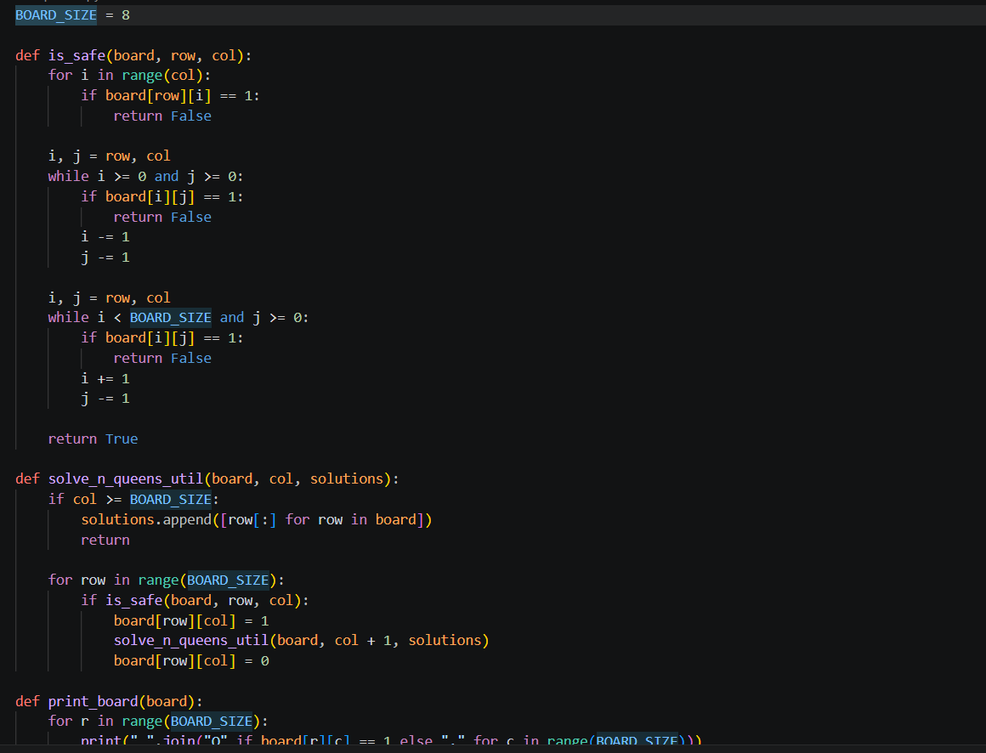
Code :
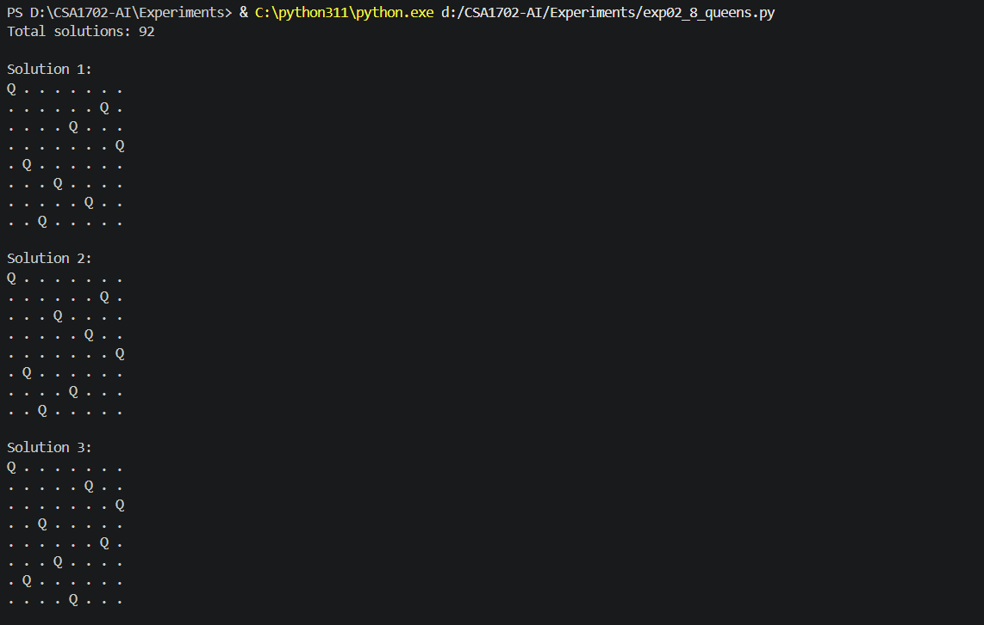
Output :
RESULT: Thus, the Python program to solve the 8-Queen Problem was executed successfully.

